Voltage Dividers
Voltage Divider ek resistor base circuit hota hai, jo bade voltage ko chote voltage me change kr deta hai.
Sirf 2 resister ko series me jodkar ek output voltage bna sakte hai.

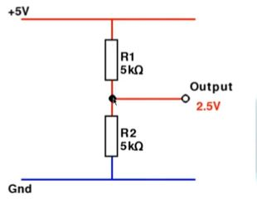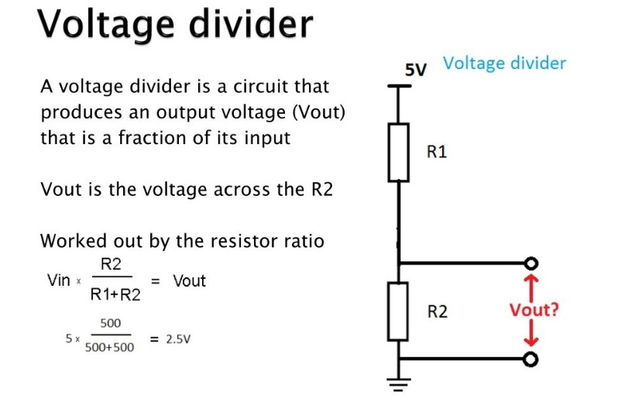

To calculate
https://ohmslawcalculator.com/voltage-divider-calculator

Pull-up Resistors
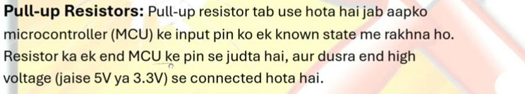
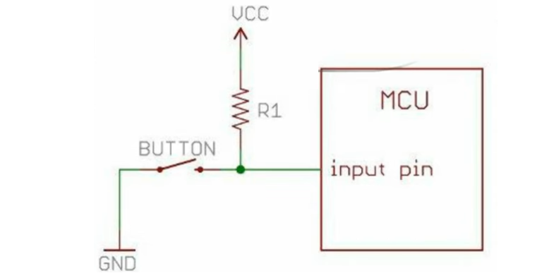

👉 Concept
Resistor signal ko VCC ki taraf kheechta hai
👉 Case
- Button open → Signal = VCC (5V)
- Button press → Signal = 0V

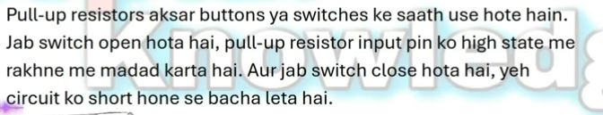
Signal ko high level par rakhane ke liye (us line ko contineously vohi voltage mile)

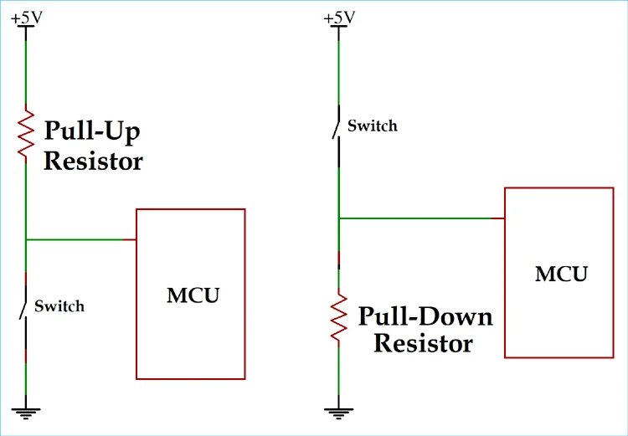

Pull-Down Resistor – Voltage
👉 Concept
Resistor signal ko GND ki taraf kheechta hai
👉 Case
- Button open → Signal = 0V
- Button press → Signal = 5V

